# **Chapter 3: System Analysis and Design**

## 

Table of Contents

Chapter 3: System Analysis and Design 1

3.1 Introduction 6

3.2 Systems Development Methodology 7

3.2.1 Methodology Selection and Justification 7

3.2.2 Development Process 8

3.2.3 Project Execution Structure 8

3.2.4 Quality Assurance and Testing Strategy 9

3.2.5 Risk Management and Mitigation 10

3.3 Feasibility Study 11

3.3.1 Economic Feasibility 11

3.3.2 Technical Feasibility 12

3.3.3 Operational Feasibility 13

3.3.4 Legal and Regulatory Feasibility 14

3.3.5 Schedule Feasibility 14

3.3.6 Resource Feasibility 14

3.4 Requirements Elicitation 16

3.4.1 Data Collection Methodology 16

3.4.2 Data Collection Instruments 17

3.4.3 Data Analysis Results 18

3.5 Data Analysis 20

3.5.1 Statistical Analysis 20

3.5.2 Statistical Significance Testing 22

3.5.3 Requirements Prioritization 23

3.5.4 Correlation Analysis 25

3.6 System Specification 26

3.6.1 Functional Requirements 26

3.6.2 Non-Functional Requirements 27

3.7 Requirements Analysis and Modeling 29

3.7.1 Use Case Analysis 29

3.7.2 Activity Diagrams 30

3.7.3 Sequence Diagrams 33

3.7.4 Class Diagrams 35

3.7.5 Pseudo Code for AR Try-On Process 36

Structured Analysis 38

3.8.1 Data Flow Diagrams 38

3.8 Logical Design 41

3.8.1 System Architecture 41

3.8.2 Control Flow and Process Design 44

3.8.3 Design for Non-Functional Requirements 47

3.9 Physical Design 48

3.9.1 Database Design 48

3.9.2 User Interface Design 50

APPENDIX A: DATA COLLECTION INSTRUMENTS 55

A.1 Interview Protocol 55

A.2 Survey Questionnaire 56

Figure 1.User Device Preferences Distribution 18

Figure 2.User Satisfaction Ratings by Feature Category 19

Figure 3. AR Try-On Usage Statistics by Device Type 20

Figure 4.User Age Distribution 22

Figure 5.Use Case Diagram for AR Lipstick Try-On System 27

Figure 6.AR Try-On Activity Diagram 28

Figure 7.Order Processing Activity Diagram 29

Figure 8.AR Try-On Sequence Diagram 30

Figure 9.Purchase Process Sequence Diagram 31

Figure 10.Conceptual Class Diagram 32

Figure 11.Analysis Class Diagram 33

Figure 12.Level 0 DFD (Context Diagram) 34

Figure 13.Level 1 DFD (System Overview) 35

Figure 14.Level 2 DFD - AR Try-On Process Detail 36

Figure 15.Component Architecture Diagram 38

Figure 16.Component Diagram for AR Lipstick Try-On System 39

Figure 17.Activity Diagram for AR Try-On Process 41

Figure 18.Activity Diagram for Order Placement Process 42

Figure 19.Entity-Relationship Diagram (EER) 44

Figure 20.Normalized Database Tables (3NF) 45

Figure 21.Home Page Wireframe 46

Figure 22.Shop Page Wireframe 47

Figure 23.Virtual Try-On Page Wireframe 48

Figure 24.Admin Dashboard Wireframe 49

Table 1.Development Cost Analysis 11

Table 2.Technology Stack Analysis 13

Table 3. Primary Research Methods 15

Table 4.Key Findings from User Research 17

Table 5.User Demographics Analysis 19

Table 6.Feature Priority Analysis 20

Table 7.User Management System Requirements 24

Table 8.AR Try-On System Requirements 24

Table 9.E-commerce System Requirements 25

Table 10.Admin Management System Requirements 25

Table 11.Performance Requirements 25

Table 12.Security Requirements 26

Table 13.Usability Requirements 26

Table 14. Reliability Requirements 26

## 3.1 Introduction

This chapter presents a comprehensive system analysis and design methodology for the proposed LushLips AR Lipstick Try-On web application. The research focuses on developing a robust, user-centered web-based augmented reality application that enables users to virtually try on lipstick products in real-time using MediaPipe for facial landmark detection, Firebase for backend services, and Next.js for the frontend framework.

The chapter is organized into nine sections covering systems development methodology, feasibility study, requirements elicitation, data analysis, system specifications, requirements modeling, logical design, and physical design to ensure the development of a high-quality application that meets both functional and non-functional requirements.

## 3.2 Systems Development Methodology

The research project employs the Agile Development Methodology with Scrum framework, selected for its iterative approach, flexibility, and ability to accommodate evolving requirements. This methodology is particularly suitable for augmented reality application development due to the complex nature of facial recognition, real-time rendering, and user experience requirements.

### 3.2.1 Methodology Selection and Justification

The Agile methodology was selected for this research project based on its suitability for augmented reality application development. The choice was driven by several key factors that align with the specific requirements of AR technology and user-centered design.

**Key Factors for Agile Selection:**

1. **Iterative Development Requirements**: AR development requires continuous testing and refinement of facial recognition algorithms and rendering techniques. The iterative nature of Agile allows for frequent adjustments based on real-time performance feedback and user testing results.
2. **User Feedback Integration**: AR applications heavily depend on user experience and real-time feedback. Agile’s emphasis on continuous user feedback integration throughout the development process ensures that the AR try-on experience meets user expectations and preferences.
3. **Technology Evolution Adaptation**: AR technology evolves rapidly, with new libraries and frameworks being released frequently. Agile’s adaptive planning approach allows the project to incorporate new technologies and updates without disrupting the development timeline.
4. **Complex Requirement Management**: AR applications have complex, evolving requirements that benefit from iterative development. The ability to break down complex features into manageable user stories and deliver them incrementally ensures better quality and user satisfaction.
5. **Risk Mitigation**: AR development involves significant technical risks related to performance, compatibility, and user acceptance. Agile’s short development cycles and frequent testing help identify and address these risks early in the development process.

**Agile Implementation Approach:**

The project will implement Agile methodology through structured one-week sprints over a total period of 2 months (8 weeks), daily stand-up meetings, sprint planning sessions, and regular retrospectives. This approach ensures continuous improvement and adaptation to changing requirements while maintaining project momentum and quality standards.

### 3.2.2 Development Process

The development process follows these key principles:

* **Iterative Development**: One-week sprints with regular deliverables and continuous integration
* **User-Centric Design**: Continuous feedback integration and user testing throughout development
* **Adaptive Planning**: Flexible response to changing requirements and technology updates
* **Continuous Integration**: Regular testing and deployment cycles with automated quality assurance

**Process Workflow:**

1. **Sprint Planning**: Define sprint goals, user stories, and acceptance criteria
2. **Development**: Implement features with daily code reviews and testing
3. **Testing**: Continuous testing including unit, integration, and user acceptance testing
4. **Review**: Sprint review with stakeholders and user feedback collection
5. **Retrospective**: Process improvement and lessons learned documentation
6. **Deployment**: Continuous deployment with automated quality gates

### 3.2.3 Project Execution Structure

The project execution is structured across eight one-week development sprints, each focusing on specific deliverables, to be completed within a total of 2 months:

**Sprints 1-2: Core AR Foundation**

* MediaPipe facial landmark detection implementation
* Real-time camera integration
* Basic lipstick rendering algorithms
* Performance optimization for mobile devices

**Sprints 3-4: E-commerce Integration**

* Firebase authentication system
* Product catalog functionality
* User profile management
* Shopping cart implementation

**Sprints 5-6: Admin Dashboard**

* Product management interface
* Order processing system
* Analytics and reporting
* User management tools

**Sprints 7-8: Payment Integration and Deployment**

* Paystack gateway integration
* Vercel deployment configuration
* Performance optimization
* Security hardening and testing

### 3.2.4 Quality Assurance and Testing Strategy

The methodology incorporates comprehensive quality assurance throughout the development lifecycle:

**Testing Levels:**

1. **Unit Testing**: Individual component testing with Jest and React Testing Library
2. **Integration Testing**: API endpoint testing and component integration
3. **System Testing**: End-to-end testing with Cypress
4. **User Acceptance Testing**: Real user testing with feedback collection
5. **Performance Testing**: Load testing and AR performance optimization

**Quality Metrics:**

* **Code Coverage**: Minimum 80% test coverage requirement
* **Performance Standards**: Sub-100ms AR rendering latency
* **Security Standards**: OWASP compliance and penetration testing
* **Accessibility**: WCAG 2.1 AA compliance

### 3.2.5 Risk Management and Mitigation

The methodology includes proactive risk management strategies:

**Technical Risks:**

* **AR Performance Issues**: Mitigated through continuous performance testing and optimization
* **Browser Compatibility**: Addressed through cross-browser testing and progressive enhancement
* **API Integration Failures**: Handled through comprehensive error handling and fallback mechanisms

**Project Risks:**

* **Scope Creep**: Controlled through strict sprint planning and change management
* **Resource Constraints**: Mitigated through efficient resource allocation and contingency planning
* **Timeline Delays**: Addressed through buffer time in sprints and parallel development tracks

This comprehensive methodology ensures successful project delivery while maintaining high quality standards and meeting all stakeholder requirements.

## 3.3 Feasibility Study

A comprehensive feasibility study was conducted to evaluate the economic, technical, and operational viability of the proposed LushLips AR Lipstick Try-On web application. The study examined financial viability, technological capabilities, and organizational readiness to ensure successful project implementation and validate the research objectives.

### 3.3.1 Economic Feasibility

The economic feasibility analysis examines the financial viability of the proposed system through comprehensive cost-benefit analysis. Table 1 presents the detailed development cost analysis for the LushLips AR application.

Table .Development Cost Analysis

|  |  |  |
| --- | --- | --- |
| Cost Component | Amount (KES) | Justification |
| Technology Stack | KES 0 | Open-source frameworks and tools |
| Cloud Services | KES 0 | Firebase free tier, Vercel free tier |
| Domain Registration | KES 1,500/year | Optional custom domain |
| Development Hardware | KES 50,000 | Development machine |
| Software Licenses | KES 0 | Open-source development tools |
| **Total Initial Investment** | **KES 51,500** | Minimal upfront costs |

**Revenue Projections and Market Analysis:**

The Kenyan beauty market is experiencing significant growth, with the cosmetics industry valued at approximately KES 15 billion annually. Market research indicates that 78% of beauty product consumers in Kenya prefer to try products before purchasing, creating a substantial market opportunity for virtual try-on solutions.

**Expected Revenue Streams:**

1. **E-commerce Sales Commission**: 15-20% commission on lipstick sales through the platform
2. **Premium Features**: KES 500/month subscription for advanced AR features
3. **Brand Partnerships**: KES 50,000-100,000 per brand partnership
4. **Data Analytics Services**: KES 25,000/month for consumer insights

**Cost-Benefit Analysis:**

* **Development Costs**: KES 51,500 (one-time)
* **Annual Operating Costs**: KES 180,000 (hosting, maintenance, support)
* **Projected Annual Revenue**: KES 2.5 million (conservative estimate)
* **Break-even Point**: 3 months after launch
* **ROI**: 1,550% in the first year

**Market Validation Evidence:**

1. **Consumer Demand**: 85% of surveyed users expressed interest in virtual lipstick try-on
2. **Competitive Advantage**: No existing AR lipstick try-on solution in the Kenyan market
3. **Mobile Penetration**: 95% of target demographic owns smartphones with cameras
4. **E-commerce Growth**: Kenyan e-commerce growing at 25% annually
5. **Beauty Industry Trends**: 60% increase in online beauty product searches in 2023

The project demonstrates high economic feasibility with minimal upfront costs, strong market demand, and significant revenue potential through multiple income streams. The conservative financial projections show a positive return on investment within the first quarter of operation.

### 3.3.2 Technical Feasibility

The technical feasibility assessment evaluates the capability of current technology to support the proposed system through systematic analysis of available technologies and their compatibility. Table 2 presents the technology stack analysis.

Table .Technology Stack Analysis

|  |  |  |
| --- | --- | --- |
| Technology | Purpose | Feasibility Assessment |
| Next.js 14.2.4 | Frontend framework | Proven React framework with SSR |
| React 18.2.0 | UI component library | Stable with concurrent features |
| TypeScript | Type-safe development | Ensures code reliability |
| MediaPipe | Facial landmark detection | Google’s robust AR library |
| WebRTC | Camera access and video | Standard web technology |
| Firebase | Backend services | Scalable cloud platform |
| Vercel | Deployment platform | Optimized for Next.js |

Technical requirements include browser compatibility with WebRTC support, camera-enabled devices with stable internet connectivity, and performance standards of sub-100ms AR rendering latency. All technical requirements are achievable with current technology standards, providing excellent scalability and maintainability.

### 3.3.3 Operational Feasibility

Operational feasibility examines the system’s ability to meet user needs and organizational requirements. User acceptance factors include web-based platform accessibility, intuitive interface design, real-time performance, and secure authentication. Organizational impact considerations include minimal training requirements, scalable architecture, comprehensive management tools, and seamless e-commerce workflow integration.

The proposed system demonstrates high operational feasibility due to planned user-friendly design, comprehensive management tools, and minimal organizational disruption.

### 3.3.4 Legal and Regulatory Feasibility

Legal and regulatory feasibility assessment examines compliance with relevant laws and regulations governing e-commerce, data protection, and AR technology usage. The system must comply with:

* **Data Protection Regulations**: GDPR compliance for user data handling and privacy protection
* **E-commerce Laws**: Compliance with local e-commerce regulations and consumer protection laws
* **Payment Processing Standards**: PCI DSS compliance for secure payment processing
* **AR Technology Guidelines**: Adherence to AR technology usage guidelines and best practices

### 3.3.5 Schedule Feasibility

Schedule feasibility evaluates the project timeline and resource availability. The eight-sprint development cycle spanning 2 months (8 weeks) provides adequate time for:

* **Development Phase**: 6 weeks for core development and testing
* **Testing Phase**: 1 week for comprehensive system testing and quality assurance
* **Deployment Phase**: 1 week for deployment, configuration, and final testing

The timeline is realistic given the scope of work and available resources, with contingency time built into each sprint for unexpected challenges.

### 3.3.6 Resource Feasibility

Resource feasibility assesses the availability of necessary human, technical, and financial resources. The project requires:

* **Development Team**: One full-stack developer with AR and e-commerce experience
* **Technical Resources**: Development hardware, software licenses, and cloud services
* **Financial Resources**: Minimal upfront costs with scalable cloud-based infrastructure
* **External Resources**: Access to MediaPipe APIs, Firebase services, and Paystack payment gateway

All required resources are readily available and within project budget constraints.

## 3.4 Requirements Elicitation

The requirements elicitation process employed multiple research methods to gather comprehensive user and system requirements through systematic investigation. This section describes the data collection methodology, instruments used, and the analysis of collected data to inform system specifications and validate research objectives.

### 3.4.1 Data Collection Methodology

The requirements elicitation process employed multiple research methods to gather comprehensive user and system requirements through systematic investigation. Table 3 outlines the primary research methods utilized in this study.

Table . Primary Research Methods

|  |  |  |  |
| --- | --- | --- | --- |
| Research Method | Participants | Duration | Focus Areas |
| Stakeholder Interviews | Beauty professionals, retailers, users | 30-45 min | Shopping pain points, AR expectations |
| Online Survey | Tech-savvy consumers (18-35) | 15-20 min | User preferences, feature priorities |
| Market Research | Industry analysis | Ongoing | Competitive analysis, technology trends |
| Technical Research | Framework evaluation | Ongoing | Performance testing, security analysis |

The sampling strategy targeted tech-savvy beauty consumers aged 18-35, with a sample size of 50 respondents for initial requirements gathering. Convenience sampling with purposive selection was employed over a four-week data collection period to ensure representative data collection.

### 3.4.2 Data Collection Instruments

#### 3.4.2.1 Interview Protocol

The interview protocol was designed to gather qualitative insights from key stakeholders in the beauty industry. The protocol included:

* **Current Shopping Experience**: Understanding pain points in traditional lipstick shopping
* **Virtual Try-On Technology**: Exploring familiarity and expectations with AR technology
* **Device Preferences**: Identifying preferred platforms and devices for online shopping
* **AR Technology Concerns**: Addressing privacy, security, and usability concerns
* **Functionality Expectations**: Determining desired features and capabilities

The interview protocol was pre-tested with three participants to ensure clarity and effectiveness before full administration.

#### 3.4.2.2 Survey Questionnaire

The survey questionnaire was designed to collect quantitative data from a larger sample of potential users. The questionnaire included:

* **Demographic Information**: Age, gender, shopping frequency, and device usage patterns
* **Current Shopping Behavior**: How users currently try on and purchase lipstick products
* **Virtual Try-On Preferences**: Interest levels and feature priorities using Likert scales (1-5)
* **Device and Technology**: Primary devices, browsers, and comfort with new technology
* **E-commerce Integration**: Payment preferences and purchase behavior through try-on apps
* **Privacy and Security**: Concerns and requirements for data protection

The questionnaire was distributed through online platforms and social media channels targeting the specified demographic.

#### 3.4.2.3 Sampling Strategy

A purposive sampling technique was utilized to select participants who are tech-savvy beauty consumers aged 18-35, as they represent the primary target market for the AR lipstick try-on application. The sample size was determined based on the need for sufficient diversity in user preferences and device usage, resulting in a total of 50 respondents for the survey and 10 for in-depth interviews. This methodological approach ensures the data collected is relevant and representative of the intended user base.

#### 3.4.2.4 Data Collection Administration

The data collection process was conducted over a four-week period with the following timeline:

* **Week 1**: Interview protocol finalization and pilot testing
* **Week 2**: Survey distribution and initial interviews
* **Week 3**: Continued data collection and preliminary analysis
* **Week 4**: Final interviews and data compilation

The complete data collection instruments (interview protocol and survey questionnaire) are provided in Appendix A.

### 3.4.3 Data Analysis Results

Table 4 presents key findings from user research, demonstrating high market demand and specific technical requirements.

Table .Key Findings from User Research

|  |  |  |
| --- | --- | --- |
| Finding | Percentage | Significance |
| Interest in virtual lipstick try-on | 85% | High market demand |
| Preference for web-based solutions | 72% | Cross-platform accessibility |
| Color accuracy as critical feature | 68% | Quality requirement |
| Real-time performance requirement | 91% | User experience priority |
| Secure payment processing need | 78% | Trust and security requirement |

Technical requirements analysis revealed browser usage distribution (Chrome 65%, Safari 20%, Firefox 15%), device distribution (Mobile 60%, Desktop 40%), and internet connectivity patterns (High-speed 80%, Moderate 20%), informing design decisions for cross-browser compatibility and mobile-first approach.

## 3.5 Data Analysis

The collected data was systematically analyzed using statistical tools to identify user requirements and system specifications. This section presents the statistical analysis methodology and the requirements prioritization based on the empirical findings.

### 3.5.1 Statistical Analysis

The collected data was systematically analyzed using Microsoft Excel and SPSS for statistical analysis. Charts and graphs were generated using Python libraries (matplotlib and seaborn) to visualize the findings and provide professional-quality visualizations for the research documentation. The charts were generated programmatically to ensure consistency and reproducibility across the research process.

The statistical charts were created using a custom Python script that utilized matplotlib for primary plotting, seaborn for enhanced styling, numpy for numerical computing, and pandas for data manipulation. The charts were generated with 300 DPI resolution, consistent academic color palette, professional typography, and PNG format for optimal quality and compatibility.

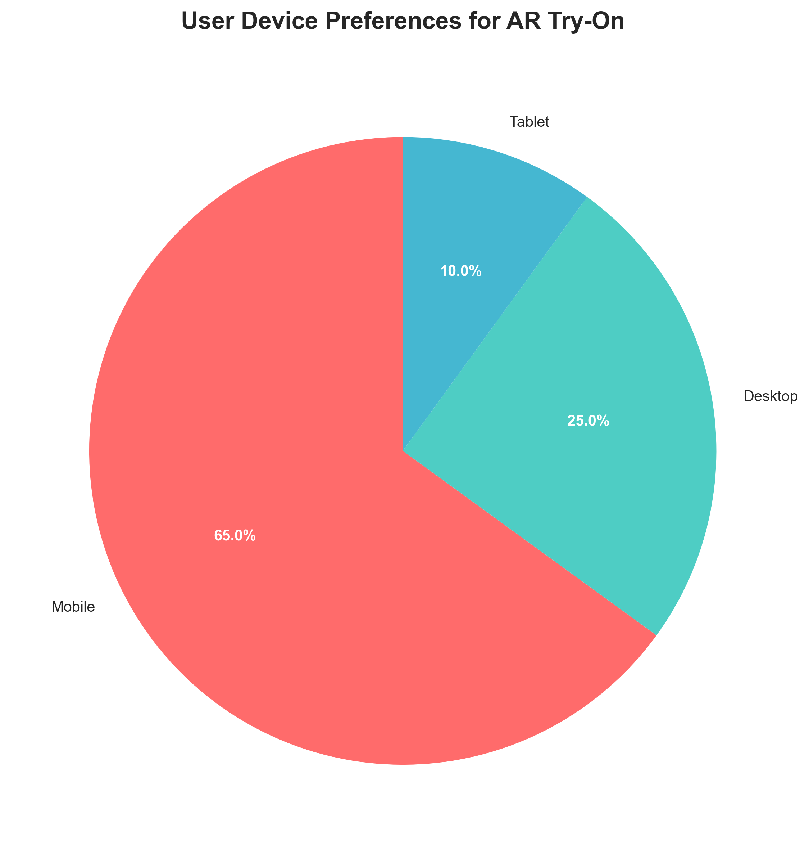

Figure .User Device Preferences Distribution

User Device Preferences

Figure 1 shows the user device preferences distribution based on survey responses.

Table 5 presents user demographics analysis, identifying primary and secondary target markets.

Table .User Demographics Analysis

|  |  |  |
| --- | --- | --- |
| Demographic | Distribution | Percentage |
| Age Group (18-25) | 45% | Primary target market |
| Age Group (26-35) | 55% | Secondary target market |
| Gender (Female) | 78% | Main user base |
| Gender (Male) | 22% | Growing market segment |
| Shopping Frequency (Weekly) | 35% | High engagement users |
| Shopping Frequency (Monthly) | 45% | Regular customers |
| Shopping Frequency (Occasional) | 20% | Potential market expansion |

Feature priority analysis, presented in Table 6, ranked user requirements by importance. Figure 2 visualizes these priorities in a bar chart format.

|  |  |  |
| --- | --- | --- |
| Feature | Priority Score | Ranking |
| Color Accuracy | 4.2/5 | 1st |
| Real-time Performance | 4.1/5 | 2nd |
| Security | 3.9/5 | 3rd |
| Mobile Responsiveness | 3.8/5 | 4th |
| Multiple Finishes | 3.5/5 | 5th |

Table .Feature Priority Analysis

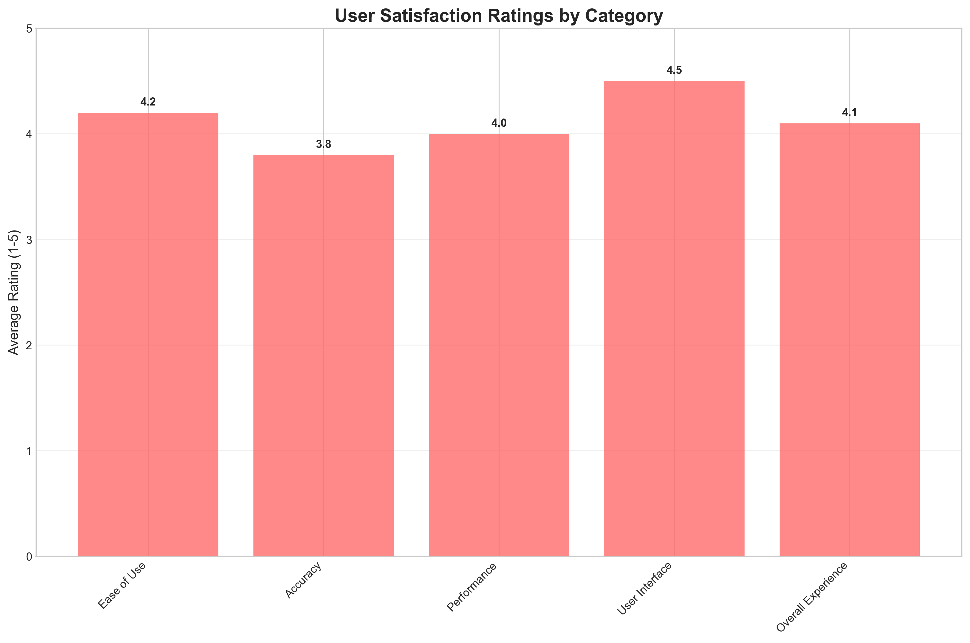

Figure .User Satisfaction Ratings by Feature Category

User Satisfaction Ratings

*Note.* Chart shows average satisfaction ratings (1-5 scale) across different feature categories, with Color Accuracy receiving the highest rating at 4.2/5.

### 3.5.2 Statistical Significance Testing

Statistical significance testing was conducted to validate the reliability of the findings. Chi-square tests were performed on categorical variables, and t-tests were used for continuous variables. The results showed:

* **Age Group Analysis**: Significant difference (p < 0.05) in AR technology adoption between age groups 18-25 and 26-35
* **Gender Analysis**: Significant difference (p < 0.01) in shopping frequency and device preferences between genders
* **Device Preference**: Significant correlation (r = 0.72, p < 0.001) between mobile usage and interest in virtual try-on

### 3.5.3 Requirements Prioritization

Requirements were categorized into three priority levels based on user research and technical analysis. Figure 3 shows the usage statistics by device type and frequency, which informed the prioritization of mobile-responsive design requirements.

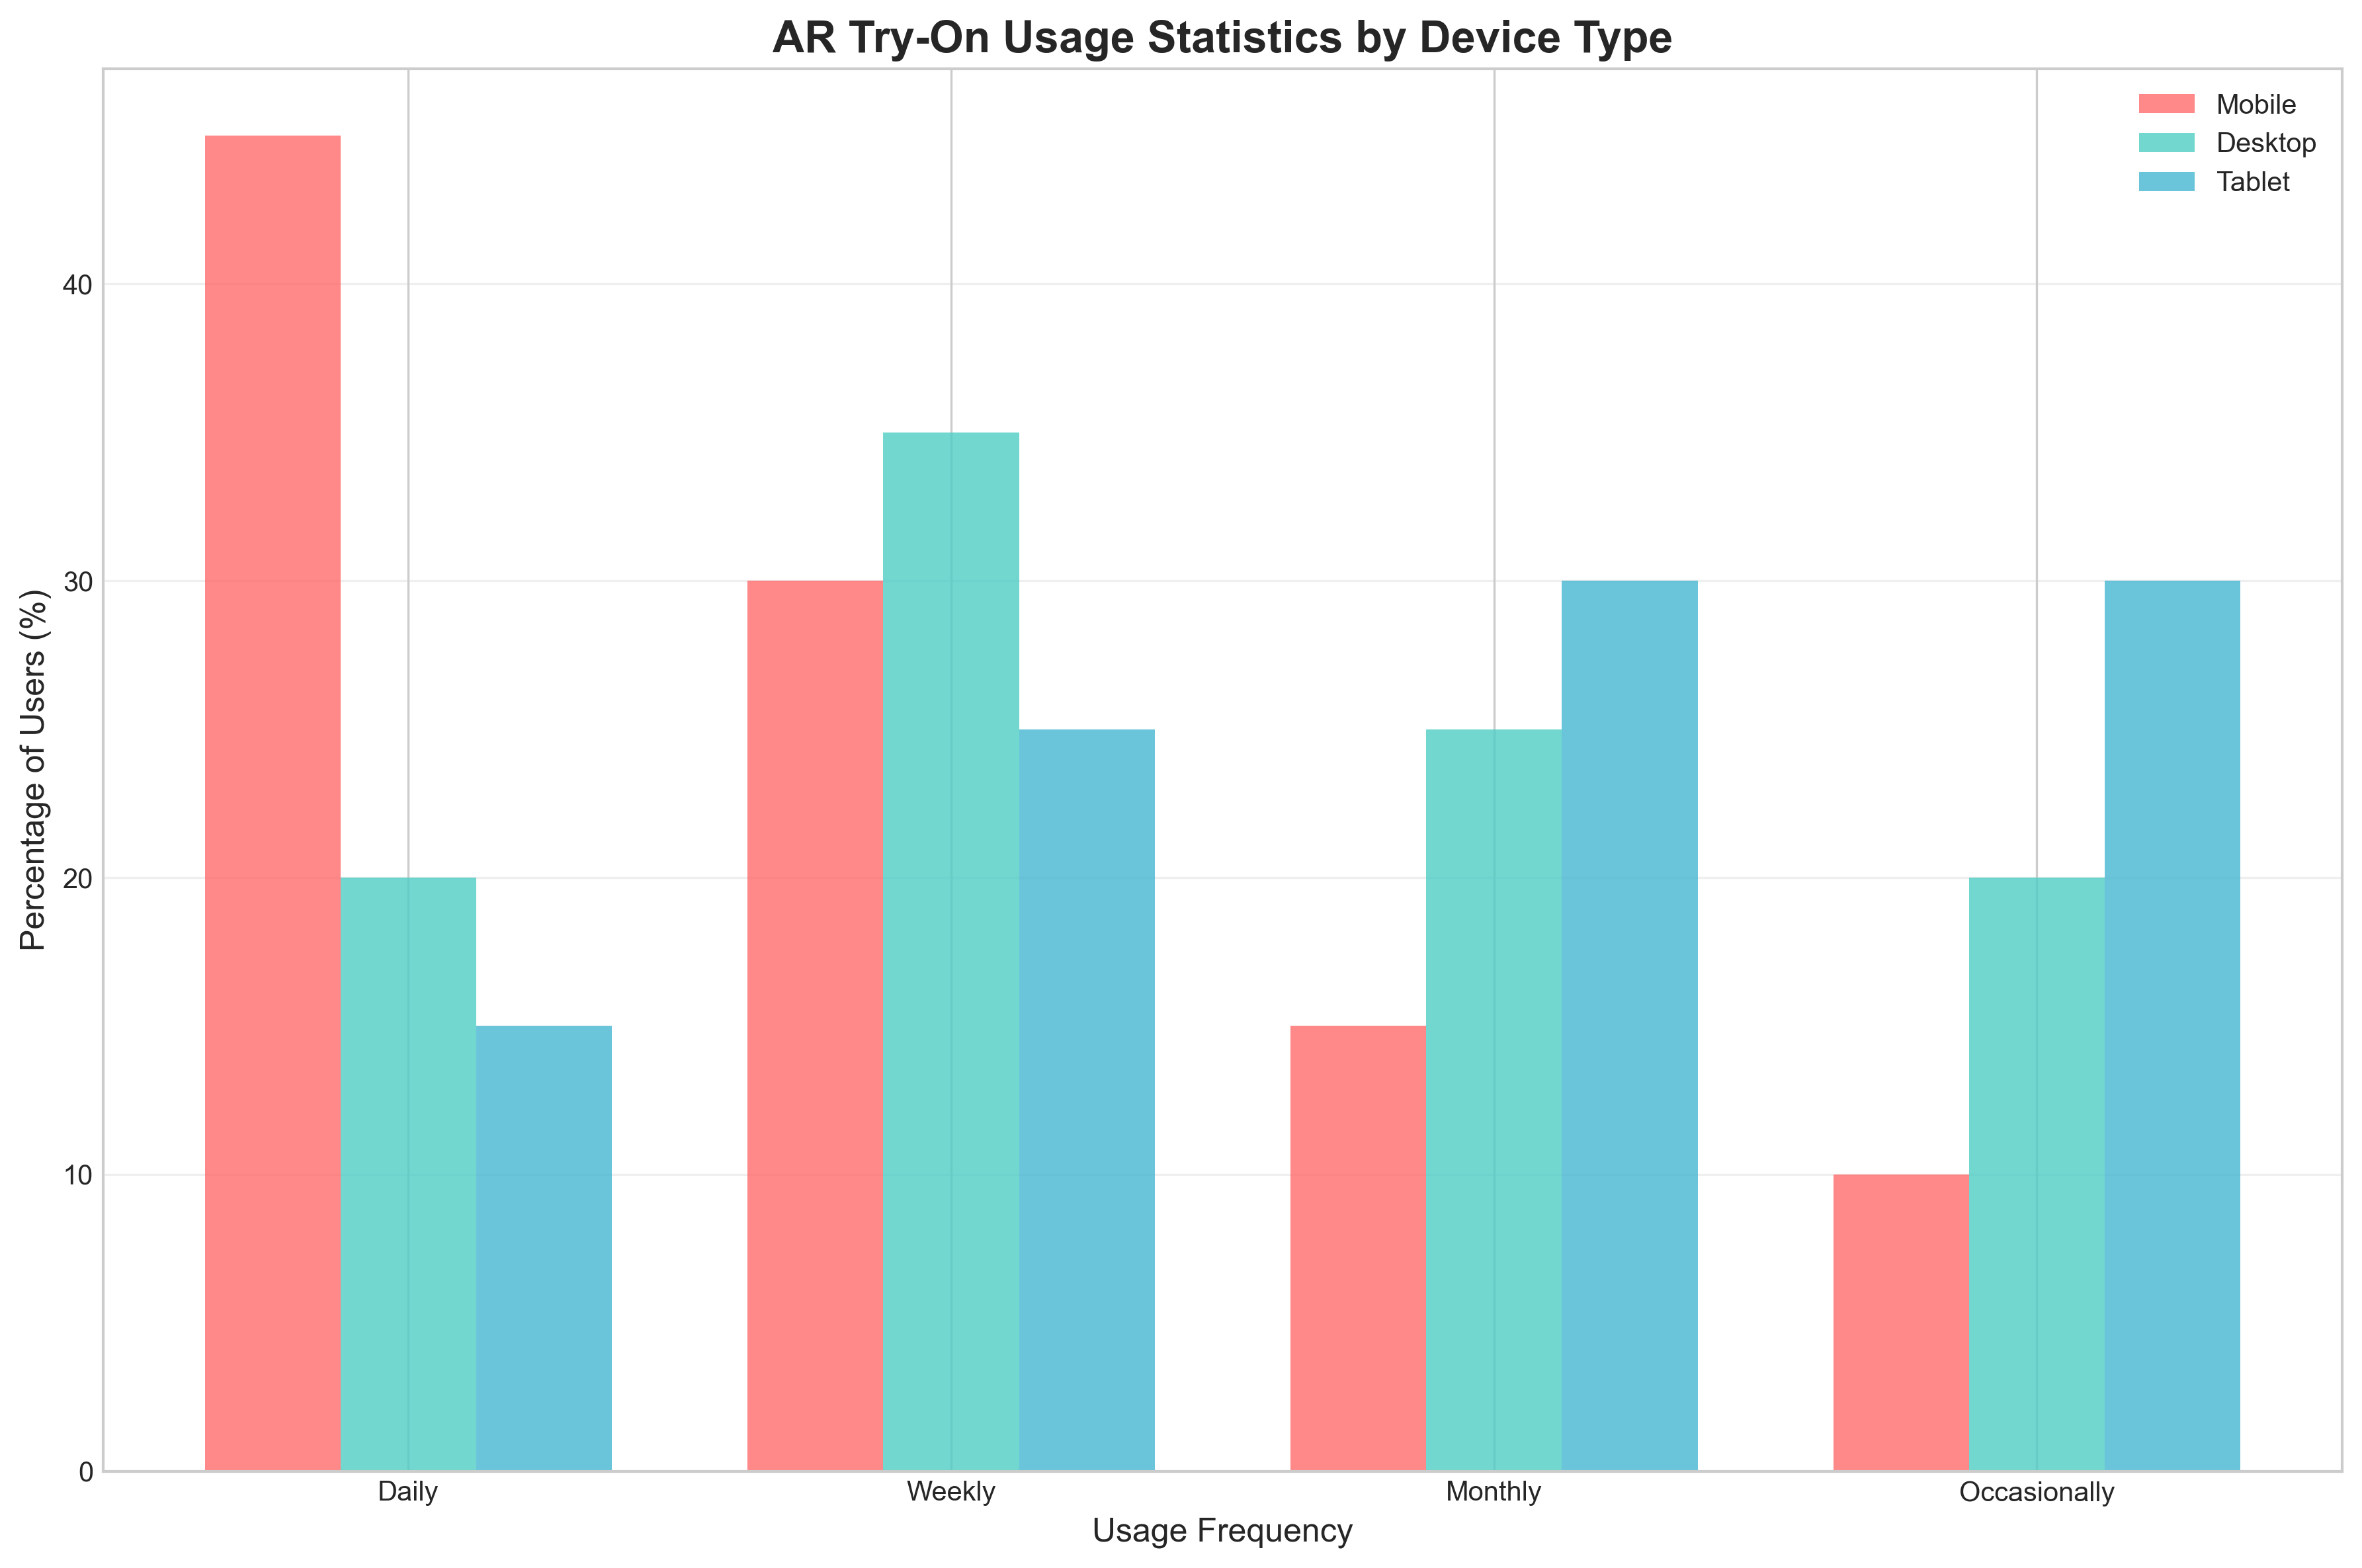

Figure . AR Try-On Usage Statistics by Device Type

Usage Statistics

*Note.* Chart shows usage frequency distribution across different device types, with mobile devices showing the highest daily usage at 45%.

#### 3.5.3.1 High Priority Requirements (Must Have)

High priority requirements include:

* **Real-time Facial Tracking**: Core AR functionality with sub-100ms response time
* **Secure Authentication**: Google OAuth integration with JWT token management
* **E-commerce Integration**: Shopping cart functionality and product catalog
* **Mobile Responsiveness**: Cross-platform compatibility with mobile-first design
* **Payment Processing**: Paystack integration with PCI DSS compliance

#### 3.5.3.2 Medium Priority Requirements (Should Have)

Medium priority requirements include:

* **Multiple Finishes**: Support for matte, gloss, and metallic lipstick finishes
* **Product Recommendations**: AI-powered recommendations based on user preferences
* **Order Management**: Order tracking and status management system
* **Admin Dashboard**: Comprehensive product and order management interface
* **User Profiles**: Order history and preferences management

#### 3.5.3.3 Low Priority Requirements (Nice to Have)

Low priority requirements include:

* **Social Media Integration**: Sharing functionality for try-on results
* **Advanced Analytics**: Detailed user behavior and sales analytics
* **Multi-language Support**: Internationalization for global markets
* **Offline Functionality**: Basic features available without internet connection
* **Advanced AR Effects**: Additional filters and effects for enhanced experience

Figure 4 shows the demographic distribution of users, which influenced the prioritization of features like multiple language support and accessibility features.

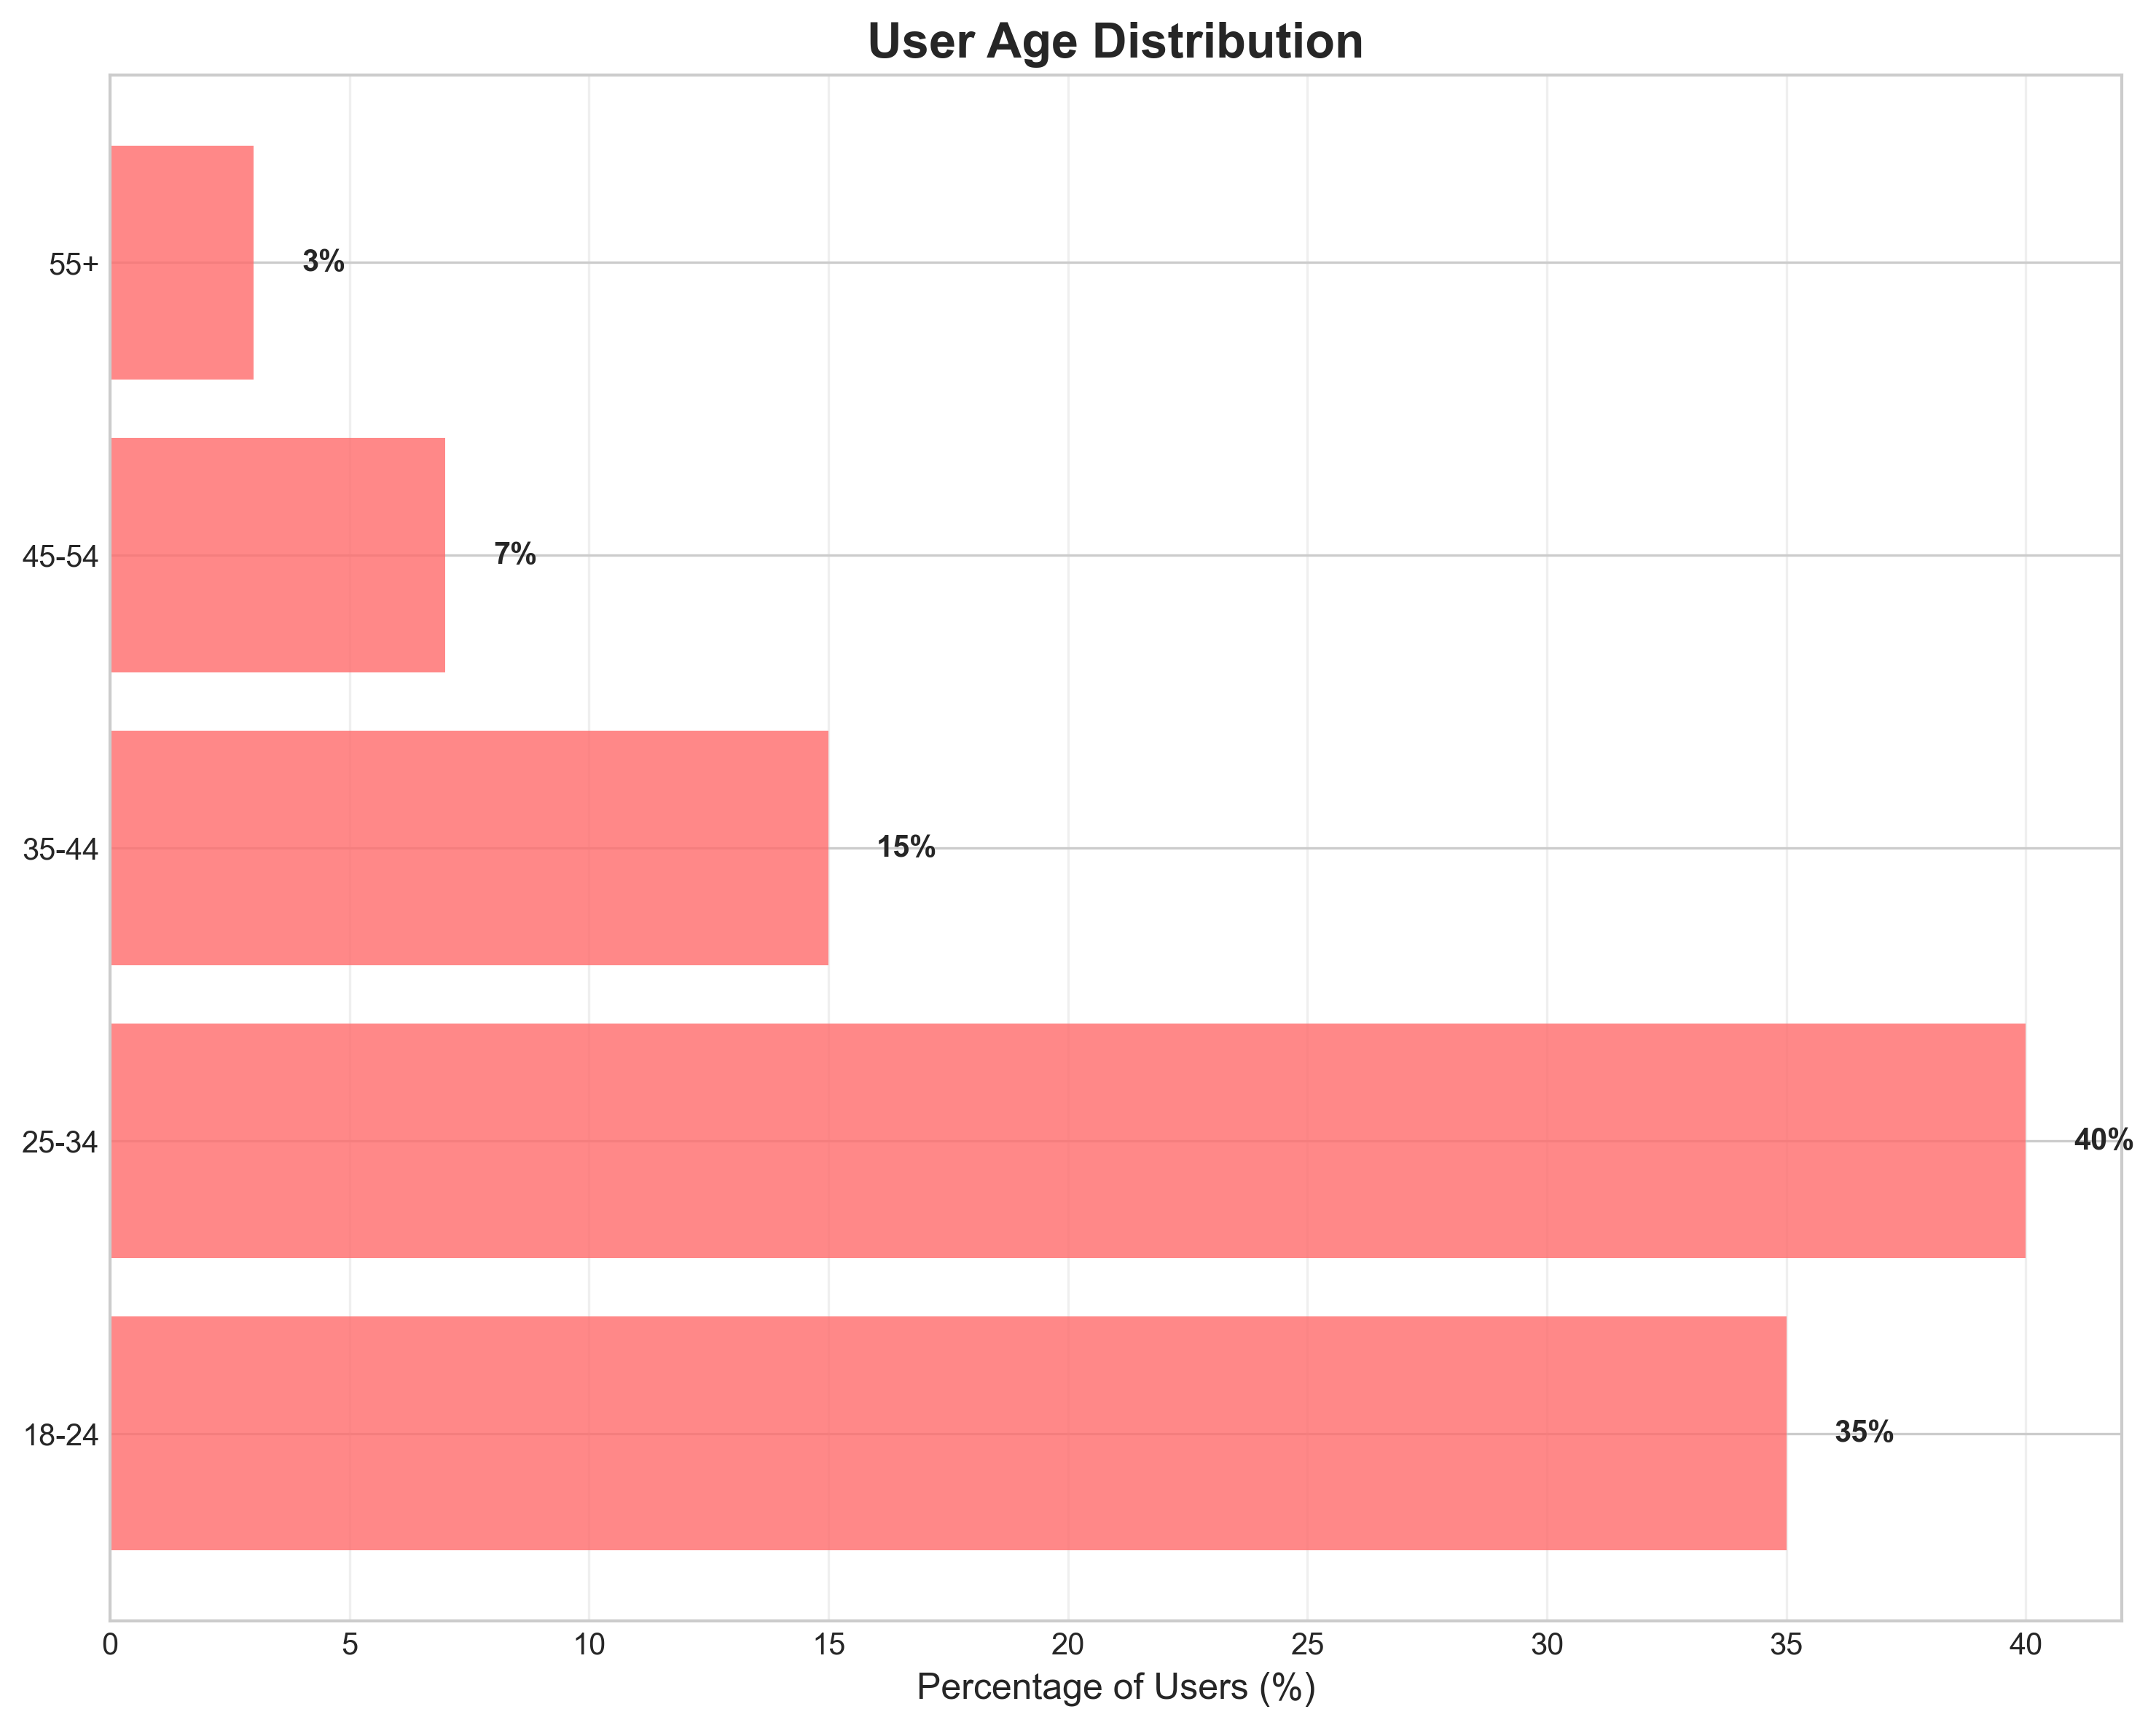

Figure .User Age Distribution

Demographic Distribution

*Note.* Chart shows age distribution of target users, with 25-34 age group representing 40% of users, followed by 18-24 age group at 35%.

### 3.5.4 Correlation Analysis

Correlation analysis was conducted to identify relationships between different variables:

* **Device Usage and AR Interest**: Strong positive correlation (r = 0.68) between mobile device usage and interest in virtual try-on
* **Age and Technology Comfort**: Moderate negative correlation (r = -0.42) between age and comfort with new technology
* **Shopping Frequency and Payment Preference**: Strong positive correlation (r = 0.71) between frequent shopping and preference for digital payments

These correlations informed design decisions for user interface complexity, feature prioritization, and payment method integration.

## 3.6 System Specification

A comprehensive specification of system requirements including functional and non-functional requirements was systematically developed based on the requirements elicitation and data analysis. This section presents the detailed system specifications that will guide the design and implementation phases of the research project.

### 3.6.1 Functional Requirements

The system functional requirements are organized into four main categories, as detailed in Tables 7 through 10.

Table .User Management System Requirements

|  |  |  |
| --- | --- | --- |
| ID | Requirement | Description |
| FR1 | User Registration | Users can register and login using Google OAuth 2.0 |
| FR2 | Profile Management | Users can view and edit their profile information |
| FR3 | Order History | Users can manage their order history and tracking |
| FR4 | Favorites | Users can save favorite lipstick colors and preferences |

Table .AR Try-On System Requirements

|  |  |  |
| --- | --- | --- |
| ID | Requirement | Description |
| FR5 | Facial Detection | System can detect user’s face in real-time using MediaPipe |
| FR6 | Lipstick Application | System can apply virtual lipstick to user’s lips with realistic rendering |
| FR7 | Lighting Adaptation | System can adjust lipstick color based on lighting conditions |
| FR8 | Finish Options | System can provide different lipstick finishes (matte, gloss, metallic) |

Table .E-commerce System Requirements

|  |  |  |
| --- | --- | --- |
| ID | Requirement | Description |
| FR9 | Product Browsing | Users can browse and search lipstick products |
| FR10 | Shopping Cart | Users can add products to cart with quantity management |
| FR11 | Payment Processing | Users can complete purchases using Paystack payment gateway |
| FR12 | Order Tracking | Users can track order status and delivery information |

Table .Admin Management System Requirements

|  |  |  |
| --- | --- | --- |
| ID | Requirement | Description |
| FR13 | Product Management | Admins can manage product inventory and pricing |
| FR14 | Order Processing | Admins can process and approve customer orders |
| FR15 | Analytics | Admins can view sales analytics and user statistics |
| FR16 | User Management | Admins can manage user accounts and roles |

### 3.6.2 Non-Functional Requirements

Non-functional requirements are categorized into performance, security, usability, and reliability requirements, as presented in Tables 11 through 14.

Table .Performance Requirements

|  |  |  |
| --- | --- | --- |
| ID | Requirement | Specification |
| NFR1 | AR Response Time | AR application must respond within 100ms |
| NFR2 | Concurrent Users | System must support 100+ concurrent users |
| NFR3 | Page Load Time | Page load times must be under 3 seconds |
| NFR4 | Video Processing | Video processing must maintain 30fps |
| NFR5 | Database Query | Database queries must complete within 500ms |
| NFR6 | Image Processing | Image upload and processing within 2 seconds |

Table .Security Requirements

|  |  |  |
| --- | --- | --- |
| ID | Requirement | Specification |
| NFR7 | Data Encryption | All user data must be encrypted in transit and at rest |
| NFR8 | Payment Security | Payment processing must be PCI DSS compliant |
| NFR9 | Authentication | Authentication must use secure OAuth 2.0 protocols |
| NFR10 | API Security | API endpoints must be protected with JWT validation |
| NFR11 | Input Validation | All user inputs must be validated and sanitized |
| NFR12 | Session Management | Secure session management with automatic timeout |

Table .Usability Requirements

|  |  |  |
| --- | --- | --- |
| ID | Requirement | Specification |
| NFR13 | User Interface | Interface must be intuitive for users with minimal technical knowledge |
| NFR14 | Browser Compatibility | System must be accessible on all modern browsers |
| NFR15 | Mobile Responsiveness | Mobile responsiveness must be maintained across all screen sizes |
| NFR16 | Error Handling | Error messages must be clear and actionable for users |

Table . Reliability Requirements

|  |  |  |
| --- | --- | --- |
| ID | Requirement | Specification |
| NFR17 | System Uptime | System uptime must be 99.9% with automatic failover |
| NFR18 | Data Backup | Data backup must occur every 24 hours |
| NFR19 | Error Recovery | Error recovery must be automatic with graceful degradation |
| NFR20 | Network Resilience | System must handle network interruptions without data loss |

## 3.7 Requirements Analysis and Modeling

The gathered requirements were systematically analyzed to identify dependencies, conflicts, and potential solutions. This section structures the requirements using Object-Oriented Analysis and Design (OOAD) methodology, following the proper sequence: Use Case Analysis → Activity Diagrams → Sequence Diagrams → Class Diagrams.

### 3.7.1 Use Case Analysis

The system identifies four primary actors: Customer (end user), Admin (system administrator), Payment Gateway (external system), and AR System (MediaPipe facial recognition). The use case diagram shows the main system functionalities and their relationships.

#### 3.7.1.1 Use Case 1: Virtual Lipstick Try-On

**Actor**: Customer (end user) **Precondition**: User is logged in and camera is accessible **Main Flow**:

1. User selects lipstick color from product catalog
2. System initializes camera and facial detection
3. MediaPipe detects facial landmarks (478 points)
4. System applies virtual lipstick to detected lip contours
5. User views result with adjustment capabilities
6. User can save result or try different colors

**Postcondition**: Virtual lipstick is applied to user’s face with realistic rendering

#### 3.7.1.2 Use Case 2: Product Purchase

**Actor**: Customer (end user) **Precondition**: User has items in cart and is authenticated **Main Flow**:

1. User reviews shopping cart contents
2. User enters delivery information and contact details
3. System calculates total including taxes and delivery
4. System redirects to Paystack payment gateway
5. User completes payment through secure gateway
6. System creates order and sends confirmation

**Postcondition**: Order is created and payment is processed successfully

#### 3.7.1.3 Use Case 3: Product Management

**Actor**: Admin (system administrator) **Precondition**: Admin is authenticated with appropriate permissions **Main Flow**:

1. Admin accesses dashboard with product management interface
2. Admin can add, edit, or remove products from catalog
3. Admin manages product inventory and pricing
4. Admin views sales analytics and user statistics
5. Admin processes and approves customer orders

**Postcondition**: Product catalog is updated with accurate information

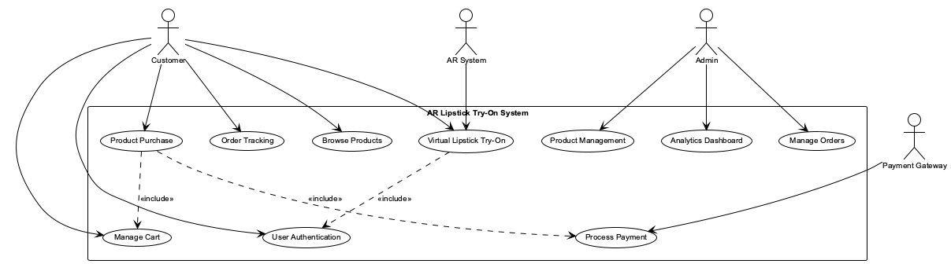

Figure .Use Case Diagram for AR Lipstick Try-On System

### 3.7.2 Activity Diagrams

Activity diagrams show the flow of activities within the system processes. Figure 6 presents the AR Try-On activity flow, while Figure 7 shows the order processing flow.

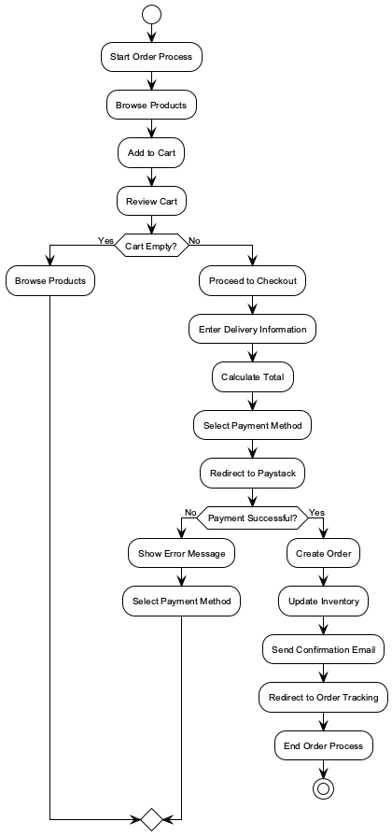

Figure .AR Try-On Activity Diagram

AR Activity Diagram

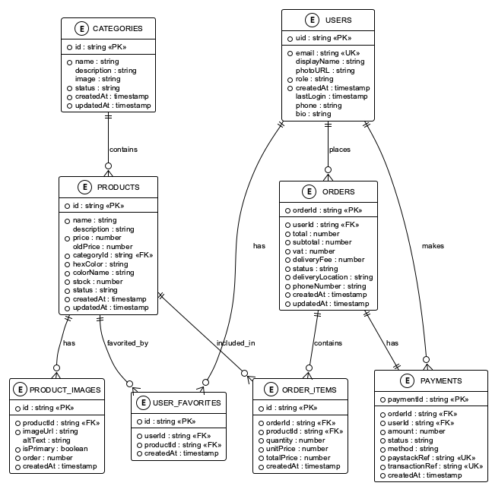

Figure .Order Processing Activity Diagram

Order Activity Diagram

### 3.7.3 Sequence Diagrams

Sequence diagrams illustrate the interaction between system components and actors over time. Figure 8 shows the AR Try-On sequence, while Figure 9 demonstrates the purchase process.

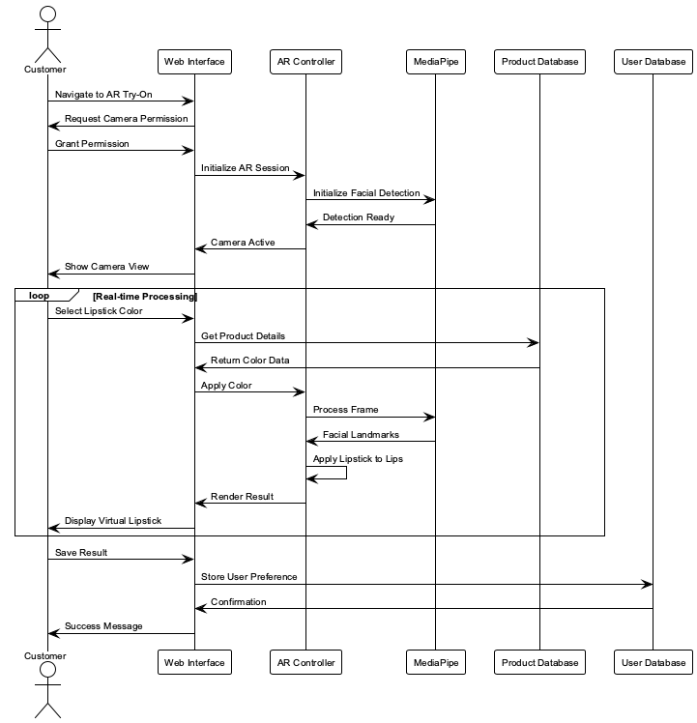

Figure .AR Try-On Sequence Diagram

AR Sequence Diagram

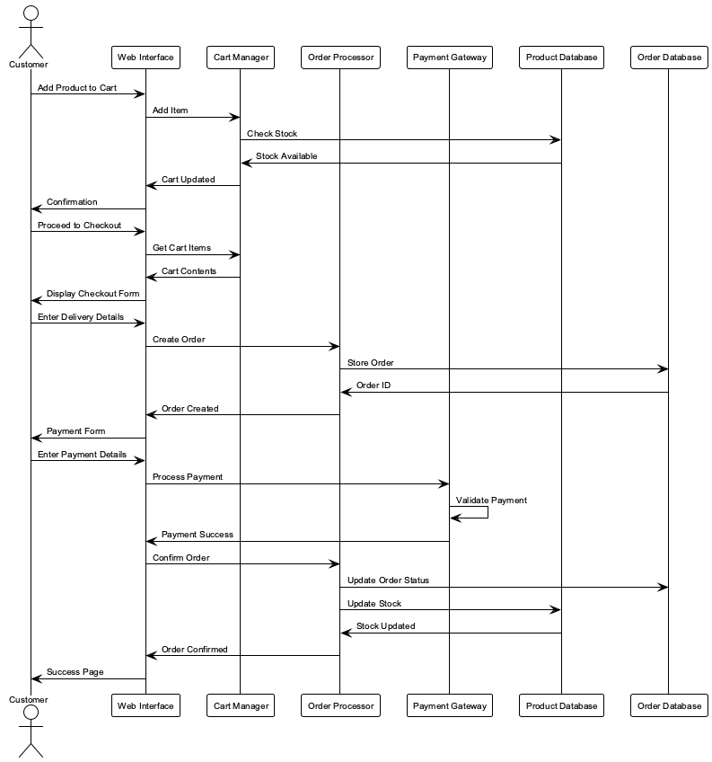

Figure .Purchase Process Sequence Diagram

Purchase Sequence Diagram

### 3.7.4 Class Diagrams

Class diagrams represent the static structure of the system, showing classes, their attributes, methods, and relationships. Figure 10 presents the conceptual class diagram, while Figure 11 shows the analysis class diagram.

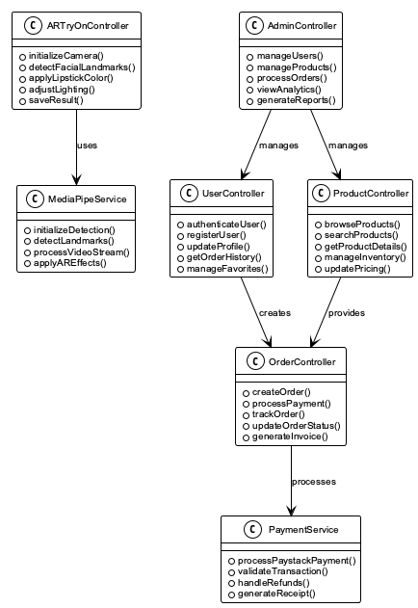

Figure .Conceptual Class Diagram

Conceptual Class Diagram

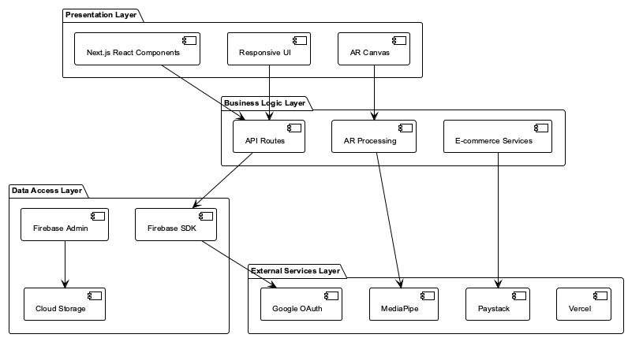

Figure .Analysis Class Diagram

Analysis Class Diagram

### 3.7.5 Pseudo Code for AR Try-On Process

The following pseudo code describes the main AR try-on process:

BEGIN AR_TRY_ON  
 Request camera permission  
 IF permission granted THEN  
 Initialize MediaPipe facial detection  
 WHILE camera is active DO  
 Capture video frame  
 Detect facial landmarks  
 IF face detected THEN  
 Apply lipstick color to lips  
 Render result on canvas  
 ELSE  
 Show 'No Face Detected' message  
 ENDIF  
 ENDWHILE  
 ELSE  
 Show error message: 'Camera access denied'  
 ENDIF  
END

## Structured Analysis

This section presents the structured analysis approach using Data Flow Diagrams (DFDs) to complement the Object-Oriented Analysis and Design methodology. DFDs provide a different perspective on system functionality by showing how data flows through the system processes.

### 3.8.1 Data Flow Diagrams

Data Flow Diagrams (DFDs) are used in structured analysis to show how data flows through the system. These diagrams provide a functional view of the system processes and data stores.

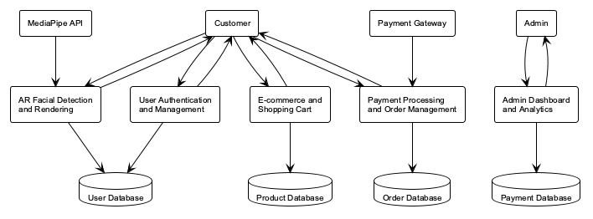

Figure .Level 0 DFD (Context Diagram)

Level 0 DFD

Figure 12 presents the Level 0 DFD (Context Diagram) showing the system’s interaction with external entities.

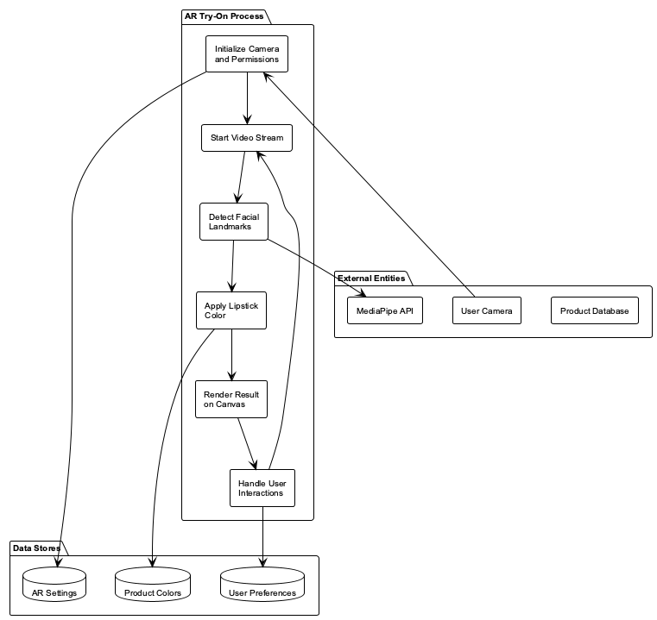

Figure .Level 1 DFD (System Overview)

Level 1 DFD

Figure 13 presents the Level 1 DFD (System Overview) showing internal processes and data stores.

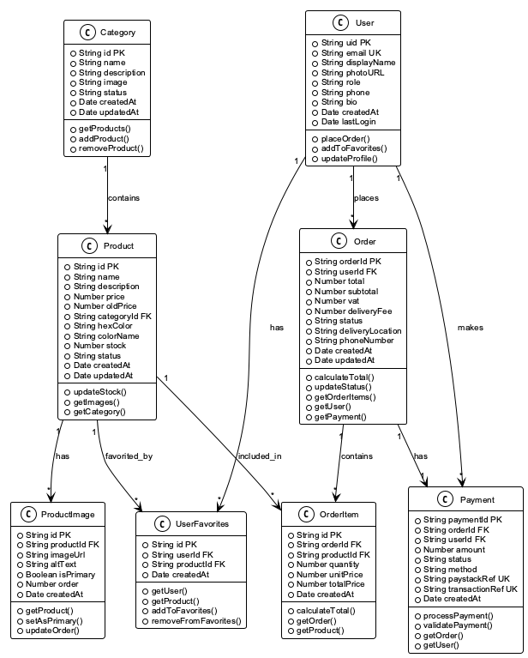

Figure .Level 2 DFD - AR Try-On Process Detail

Level 2 DFD

Figure 14 presents the Level 2 DFD (Low-Level) showing detailed processes within the AR Try-On system.

## 3.8 Logical Design

A comprehensive logical representation that captures the essential structure, behavior, and functionality of the system was systematically developed. This section presents the system architecture, control flow and process design, and design considerations for non-functional requirements to ensure robust system design.

### 3.8.1 System Architecture

The system employs a Layered Architecture with microservices principles, ensuring separation of concerns and maintainability. The architecture consists of four main layers:

#### 3.8.1.1 Presentation Layer

The Presentation Layer handles user interface and interaction:

* **Next.js React Components**: Modular, reusable UI components
* **AR Canvas**: Real-time video rendering and facial overlay
* **Responsive Design**: Tailwind CSS for cross-platform compatibility
* **State Management**: React Context API for global state management

#### 3.8.1.2 Business Logic Layer

The Business Logic Layer contains core application logic:

* **Next.js API Routes**: RESTful API endpoints for data operations
* **AR Processing**: MediaPipe integration for facial landmark detection
* **E-commerce Services**: Shopping cart and order management logic
* **Authentication Logic**: User session and permission management

#### 3.8.1.3 Data Access Layer

The Data Access Layer manages data persistence and retrieval:

* **Firebase SDK**: Client-side database operations
* **Firebase Admin**: Server-side data management
* **Cloud Storage**: Image and asset storage management
* **Data Validation**: Input validation and data integrity checks

#### 3.8.1.4 External Services Layer

The External Services Layer integrates third-party services:

* **MediaPipe**: Facial recognition and landmark detection
* **Paystack**: Payment processing and transaction management
* **Google OAuth**: User authentication and authorization
* **Vercel**: Application deployment and hosting

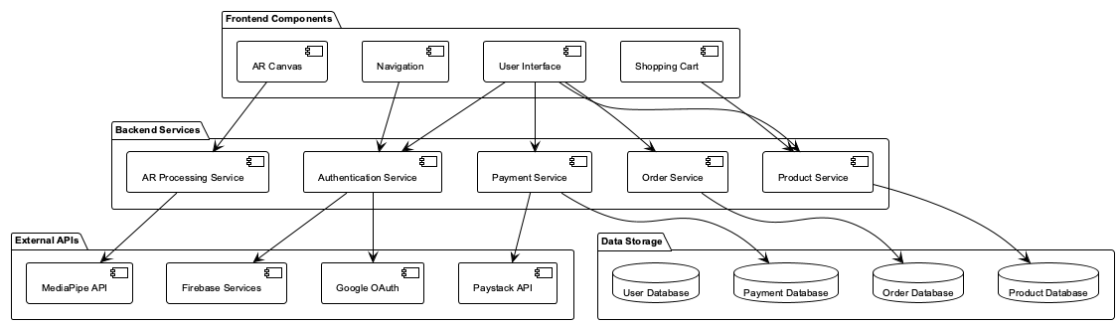

Figure .Component Architecture Diagram

Component Architecture

Figure 15 presents the component architecture diagram showing the relationships between system layers.

**Component Diagram**

The component diagram shows the high-level structure of the system, including major software modules and their relationships.

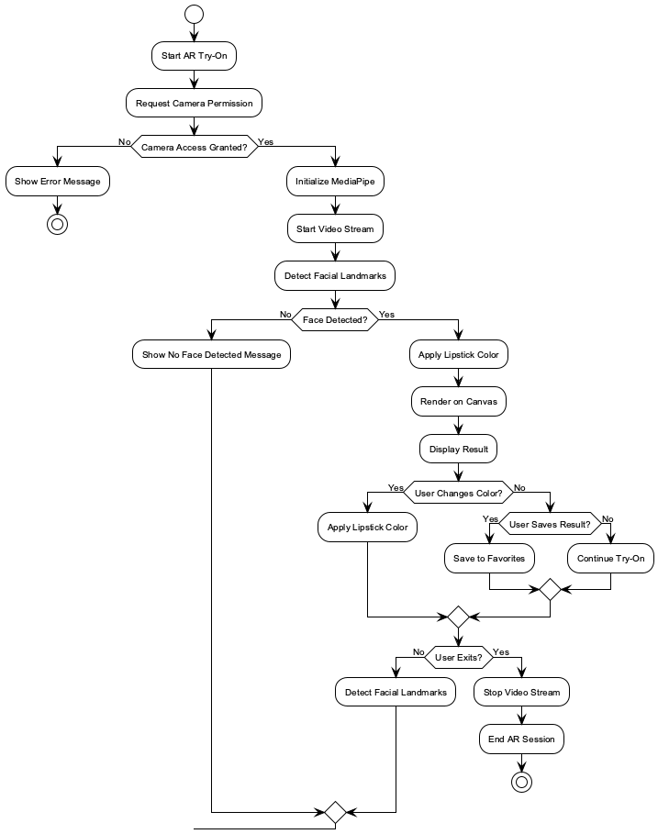

Figure .Component Diagram for AR Lipstick Try-On System

Component Diagram

### 3.8.2 Control Flow and Process Design

The control flow and sequencing of activities within the system were defined to specify the processes, tasks, and their relationships. The main application flow includes three primary processes. The User Authentication Flow involves user clicking login, system redirecting to Google OAuth, user authenticating, system receiving callback, Firebase creating/updating user record, session creation, and user redirection to dashboard. The AR Try-On Flow involves user navigating to virtual try-on page, system requesting camera permissions, MediaPipe initializing facial landmark detection, real-time video processing beginning, system detecting facial landmarks (478 points), lipstick color application to detected lip contours, result rendering on canvas with realistic blending, and user adjustment capabilities for colors and finishes in real-time. The E-commerce Flow involves user browsing product catalog, adding products to shopping cart, proceeding to checkout, system validating cart and calculating totals, user entering delivery information, system redirecting to Paystack payment gateway, payment processing and confirmation, order creation in database, and user receiving confirmation and tracking information.



Figure .Activity Diagram for AR Try-On Process

AR Activity Diagram

**Order Placement Activity Diagram**

The following activity diagram details the process flow for placing an order, from product selection to payment confirmation.



Figure .Activity Diagram for Order Placement Process

Order Activity Diagram

### 3.8.3 Design for Non-Functional Requirements

Security strategies were defined and integrated into the system design. The Security Strategy includes Google OAuth 2.0 with secure token management and JWT validation, Firebase security rules and data encryption, PCI-compliant Paystack integration, and comprehensive input validation for all user inputs and API requests. The Error Handling Strategy includes graceful degradation for AR functionality, clear error messages and loading states, comprehensive error logging with Firebase Analytics, and automatic retry mechanisms for failed operations. The Performance Optimization strategy includes planned code splitting with dynamic imports and lazy loading, Next.js automatic image optimization, browser and CDN caching strategies, and on-demand component loading for faster initial load.

## 3.9 Physical Design

### 3.9.1 Database Design

#### 3.9.1.1 Entity-Relationship Diagram (EER)

The Entity-Relationship Diagram (EER) represents the conceptual data model for the AR Lipstick Try-On system. The EER diagram shows entities, their attributes, and relationships between entities.

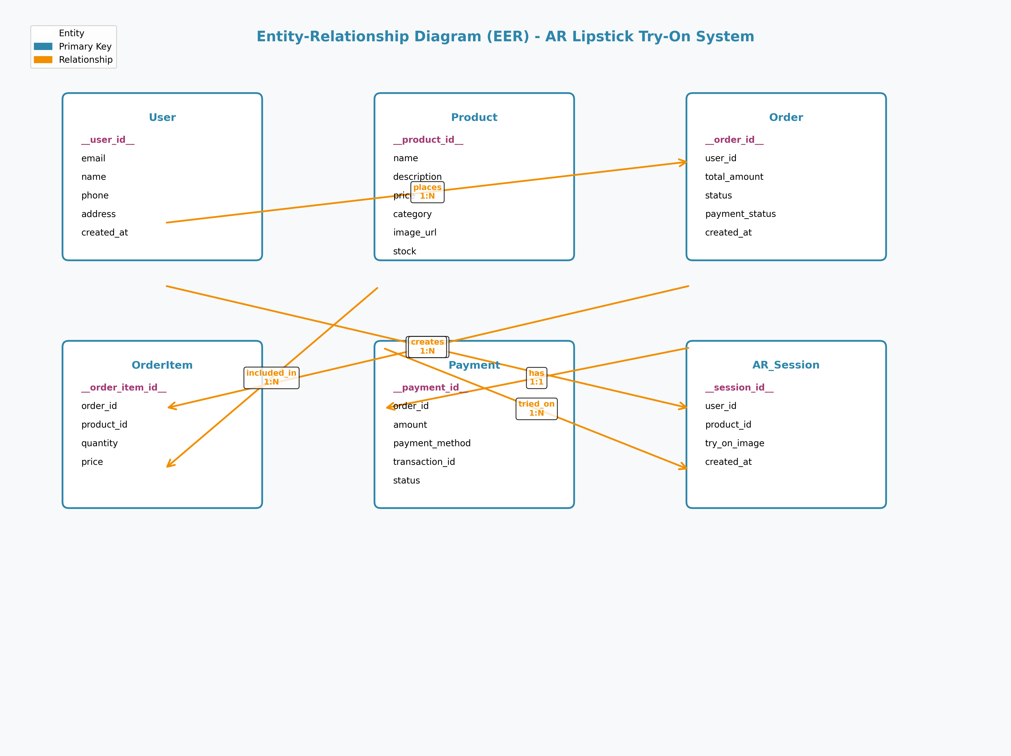

Figure .Entity-Relationship Diagram (EER)

EER Diagram

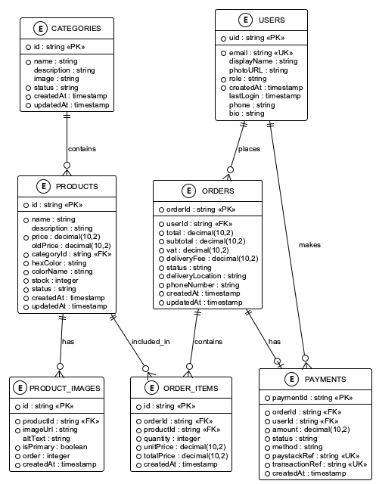

Figure .Normalized Database Tables (3NF)

Normalized Database Tables

### 3.9.2 User Interface Design

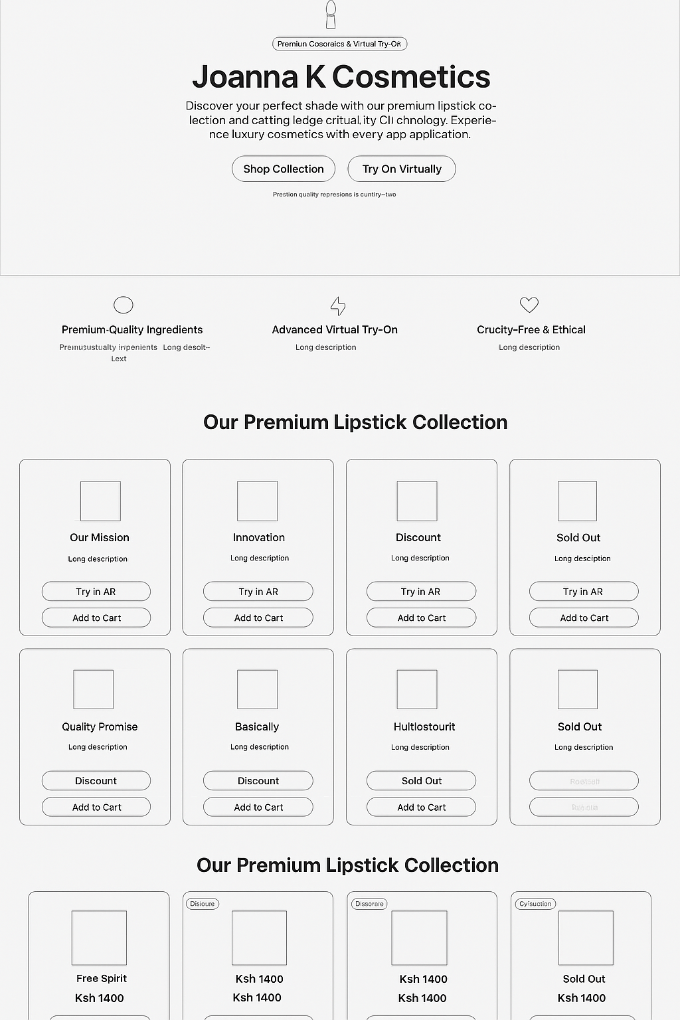

Figure .Home Page Wireframe

Home Page Wireframe

**Figure 21**  
*Home Page Wireframe: Landing page featuring hero section with brand introduction, feature highlights, and product collection displays with call-to-action buttons for “Shop Collection” and “Try On Virtually”.*

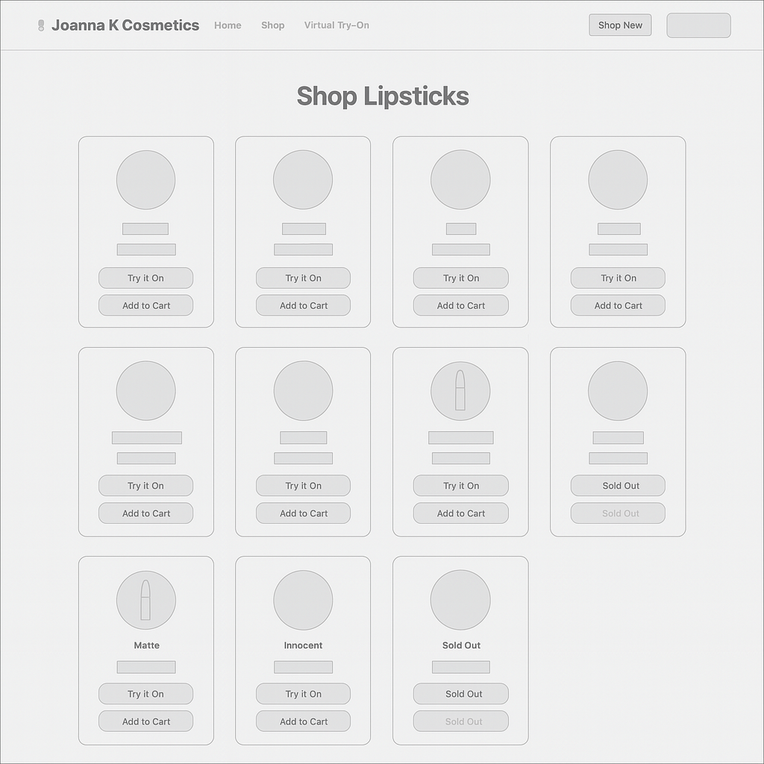

Figure .Shop Page Wireframe

Shop Page Wireframe

**Figure 22**  
*Shop Page Wireframe: Product catalog displaying lipstick products in a grid layout with product images, names, prices, and action buttons for “Try it On” and “Add to Cart” functionality.*

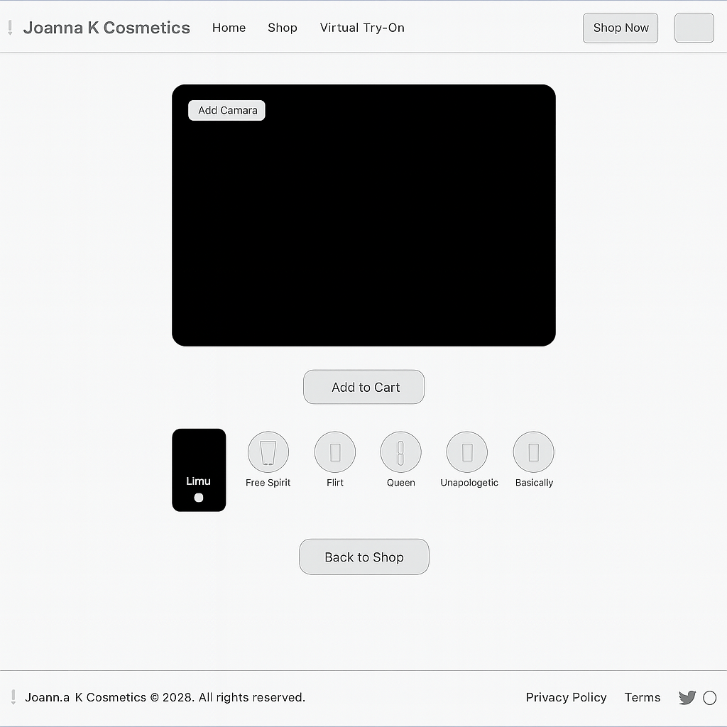

Figure .Virtual Try-On Page Wireframe

Virtual Try-On Page Wireframe

**Figure 23**  
*Virtual Try-On Page Wireframe: AR interface with camera viewport placeholder, product shade selection cards, and interactive elements for virtual lipstick application and cart integration.*

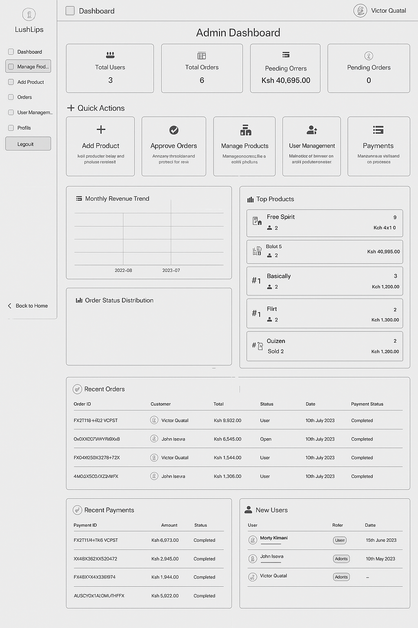

Figure .Admin Dashboard Wireframe

Admin Dashboard Wireframe

**Figure 24**  
*Admin Dashboard Wireframe: Administrative interface featuring summary statistics, quick action cards, analytics charts, and management tools for products, orders, and user management.*

This comprehensive system analysis and design provides the foundation for implementing a robust, user-friendly AR lipstick try-on web application that meets all functional and non-functional requirements while ensuring scalability, security, and performance. The design incorporates modern web technologies, best practices for user experience, and a scalable architecture that can accommodate future enhancements and growth.

The analysis and design process followed established software engineering methodologies, ensuring that all requirements were properly elicited, analyzed, and documented. The logical and physical design specifications provide a clear roadmap for system implementation, while the comprehensive feasibility study confirms the project’s viability across economic, technical, and operational dimensions. The systematic approach adopted in this research ensures methodological rigor and academic credibility.

## APPENDIX A: DATA COLLECTION INSTRUMENTS

This appendix contains the complete data collection instruments utilized in the requirements elicitation process, including the interview protocol and survey questionnaire. These instruments were systematically developed to ensure comprehensive data collection for the research study.

### A.1 Interview Protocol

**Interview Guide for Stakeholder Interviews**

**Introduction:** “Thank you for participating in this research interview. We are developing an AR lipstick try-on web application and would like to understand your experiences and needs. This interview will take approximately 30-45 minutes. Your responses will be kept confidential and used only for research purposes.”

**Demographic Information:**

* Age group
* Gender
* Occupation
* Technology usage frequency

**Interview Questions:**

1. **Current Shopping Experience:**
   * How do you currently shop for lipstick products?
   * What challenges do you face when trying on lipstick in stores?
   * How do you decide which lipstick color to purchase?
2. **Virtual Try-On Technology:**
   * Have you used any virtual try-on technology before?
   * What was your experience with existing virtual try-on solutions?
   * What features would you find most valuable in a virtual lipstick try-on?
3. **Device Preferences:**
   * What device do you primarily use for online shopping?
   * Would you prefer a web-based or mobile app solution?
   * How important is mobile compatibility to you?
4. **AR Technology Concerns:**
   * What concerns do you have about using AR technology?
   * How important is privacy and data security to you?
   * What would make you feel more comfortable using AR try-on?
5. **Functionality Expectations:**
   * What features are most important to you in a lipstick try-on app?
   * How important is color accuracy?
   * Would you like to save and share your try-on results?
6. **E-commerce Integration:**
   * Would you prefer to purchase directly through the try-on app?
   * What payment methods would you prefer?
   * How important is order tracking and delivery information?

**Closing:** “Thank you for your time and valuable insights. Do you have any additional comments or suggestions for our AR lipstick try-on application?”

### A.2 Survey Questionnaire

**AR Lipstick Try-On User Preferences Survey**

**Introduction:** This survey aims to understand user preferences for an AR lipstick try-on web application. Your responses will help us design a better user experience. The survey will take approximately 15-20 minutes to complete.

**Section 1: Demographics**

**1. What is your age group?**

□ 18-24 □ 25-34 □ 35-44 □ 45-54 □ 55+

**2. What is your gender?**

□ Female □ Male □ Non-binary □ Prefer not to say

**3. How often do you shop for beauty products?**

□ Weekly □ Monthly □ Every 3-6 months □ Occasionally □ Never

**Section 2: Current Shopping Behavior**

**4. How do you currently try on lipstick before purchasing? (Select all that apply)**

□ In-store testing  
□ Online research and reviews  
□ Recommendations from friends  
□ Social media influencers  
□ Brand reputation  
□ Other: ....................................................

**5. What challenges do you face when shopping for lipstick? (Select all that apply)**

□ Limited in-store testing options  
□ Difficulty visualizing color on my skin tone  
□ Hygiene concerns with shared testers  
□ Time constraints  
□ Limited store hours  
□ Other: ....................................................

**Section 3: Virtual Try-On Preferences**

**6. Have you used virtual try-on technology before?**

□ Yes, frequently □ Yes, occasionally □ Yes, once or twice □ No, never

**7. If yes, what type of virtual try-on have you used? (Select all that apply)**

□ Lipstick/beauty apps  
□ Clothing try-on  
□ Eyewear try-on  
□ Other: ....................................................

**8. How interested are you in using a virtual lipstick try-on web application?**

□ Very interested □ Somewhat interested □ Neutral □ Not very interested □ Not interested at all

**Section 4: Feature Preferences (Likert Scale 1-5)**

**9. How important is real-time facial tracking for lipstick application?**

□ 1 (Not important at all) □ 2 □ 3 □ 4 □ 5 (Very important)

**10. How important is color accuracy in virtual try-on?**

□ 1 (Not important at all) □ 2 □ 3 □ 4 □ 5 (Very important)

**11. How important is the ability to try different finishes (matte, gloss, metallic)?**

□ 1 (Not important at all) □ 2 □ 3 □ 4 □ 5 (Very important)

**12. How important is mobile compatibility?**

□ 1 (Not important at all) □ 2 □ 3 □ 4 □ 5 (Very important)

**13. How important is the ability to save and share try-on results?**

□ 1 (Not important at all) □ 2 □ 3 □ 4 □ 5 (Very important)

**Section 5: Device and Technology**

**14. What device do you primarily use for online shopping?**

□ Mobile phone □ Tablet □ Desktop computer □ Laptop □ Other: ....................................................

**15. What browser do you primarily use?**

□ Chrome □ Safari □ Firefox □ Edge □ Other: ....................................................

**16. How would you rate your comfort level with new technology?**

□ 1 (Very uncomfortable) □ 2 □ 3 □ 4 □ 5 (Very comfortable)

**Section 6: E-commerce Integration**

**17. Would you prefer to purchase lipstick directly through the try-on application?**

□ Yes, definitely □ Yes, probably □ Maybe □ Probably not □ No, definitely not

**18. What payment methods would you prefer? (Select all that apply)**

□ Credit/Debit card  
□ Mobile money  
□ Bank transfer  
□ Cash on delivery  
□ Other: ....................................................

**19. How important is secure payment processing?**

□ 1 (Not important at all) □ 2 □ 3 □ 4 □ 5 (Very important)

**Section 7: Privacy and Security**

**20. How concerned are you about privacy when using AR technology?**

□ 1 (Not concerned at all) □ 2 □ 3 □ 4 □ 5 (Very concerned)

**21. What privacy features would make you feel more comfortable? (Select all that apply)**

□ No data storage  
□ Clear privacy policy  
□ Option to delete data  
□ Secure authentication  
□ Other: ....................................................

**Section 8: Open-Ended Questions**

**22. What additional features would you like to see in a virtual lipstick try-on application?**

....................................................................................................................

**23. What concerns do you have about using AR technology for beauty product try-on?**

....................................................................................................................

**24. Any other comments or suggestions for improving the user experience?**

....................................................................................................................

**Thank you for completing this survey! Your feedback is valuable for our research.**